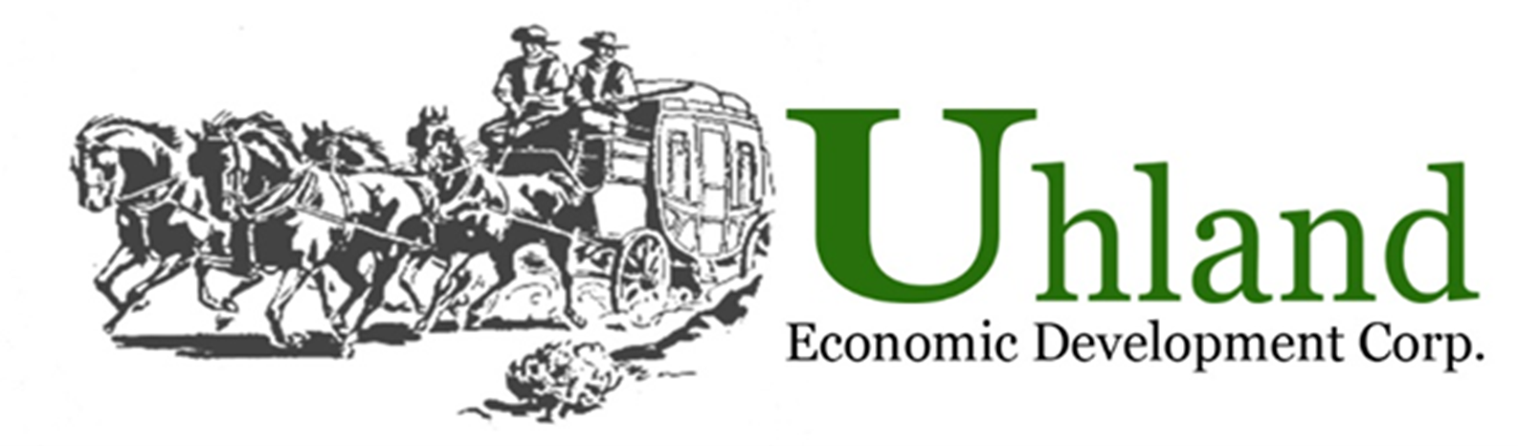
15 North Old Spanish Trail
Uhland, TX 78640
contact@uhlandedc.com

Grant Availability

To help property owners and businesses improve the overall image and enhance the economic vitality in Uhland, matching grants (40% matching funds from the Uhland EDC; provided as reimbursements after project is completed satisfactorily) are available, subject to a cost/benefit analysis. Complete Business Incentives Application and submit to the Uhland EDC.

Signage: 60% business 40% EDC. Maximum grant amount is $1,000
Signs must be individual metal, plastic, or wood letters. A sign containing neon lights, is backlit, or has a plastic face is allowed. No plywood signs are allowed. All signs shall be subject to sign permits and review as provided in the City of Uhland sign ordinance (# 28), which allows for 4’X8’ signs.

Storefront: 60% business 40% EDC. Maximum grant amount is 1,000
Exterior improvements such as awnings, painting, murals, installation of new doors and windows and other improvements are eligible. All storefront improvements shall be subject to building permits and review as provided in the City of Uhland under City ordinances building codes.

Landscaping: 60% business 40% EDC Maximum grant amount is $1,000
Permanent business landscaping improvements visible to traffic and in accordance with the City of Uhland landscaping ordinance are eligible. All landscaping improvements shall be subject to building permits and review as provided in the City of Uhland ordinance (#135). Maintenance and upkeep of landscaping shall be the sole responsibility of the applicant.

Lighting: 60% business 40% EDC. Maximum grant amount is $500.00
Exterior lighting only. City of Uhland ordinance (#134)

Please see CityofUhland.com for city ordinances

