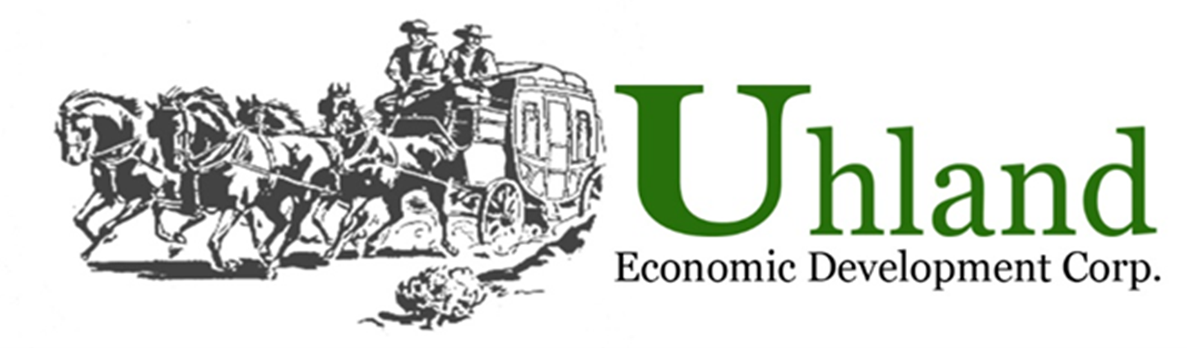
15 North Old Spanish Trail
Uhland, TX 78640
contact@uhlandedc.com

Property Tax Phase-In Program
The City of Uhland offers property tax phase-ins for retail, new or expanded commercial or industrial construction, as well as business personal property taxes associated with real property. City property tax phase-ins are granted through a contract approved by the City Council. After qualification, the City will assist applicants in seeking phase-in agreements with the other taxing authorities, based on cost benefits to the City.
Additional Considerations

If upon initial application a project qualifies for a tax phase-in under the guidelines set forth in this policy, the City Council may consider granting an additional 5% abatement for each one of the following factors provided, however, the total phase-in will not exceed 25% annually or continue for a period of more than five (5) years. No applicant may receive credit for more than five (5) of the following factors:

- The project will occupy a building that has been vacant for at least two (2) years.
- The project will create high-skilled, high-paying jobs as documented by the applicant.
- At least 25% of the new jobs created by the project will be filled by Uhland residents.
- The project will create improvements in the Uhland Downtown area.
- The project wages for employees are at least $12.00 per hour base rate for all businesses.
- The project significantly uses local contractors and suppliers both during construction and in its business operation.
- The business is a certified Small, Minority, or Woman owned business.

Level of Incentives
Incentives established for any project will be provided to the extent that the revenue realized by the City and attributable to the project exceeds a minimum amount established in the Economic Development Agreement to be entered into by the City and the applicant. The public benefit or amount of revenue realized by the City and attributable to the project must equal or exceed the value of any incentives granted under the application.

Case-by-Case Evaluation
Nothing in these policies, procedures or the application forms shall imply or suggest, or be construed to imply or suggest that the City of Uhland is under any obligation to provide any incentive to any applicant. All applicants for tax phase-ins and/or other economic development incentives shall be considered on an individual case-by-case basis.

